**Site Traffic Management Plan**

The Lodge @ Meadowcroft School

2 Leeds Road

Wakefield

WF13JT

Info@meadowcroftschool.com

**Contents**

1. Introduction
2. Layout / Access
3. School Timings
4. Pupils / Students
5. Parents
6. Staff/Visitors
7. Servicing / Deliveries
8. Outside the School Grounds
9. Management Practices

# Introduction

This document has been prepared to inform and instruct employees, pupils, parents/carers and others who come onto the site, including visitors (both pedestrians and people in vehicles), about the site rules concerning pedestrian and vehicle separation.

Meadowcroft School takes the health and safety of all site users very seriously. It is, therefore, imperative that individuals take care, exercise caution when in the school grounds or within the vicinity of the school grounds and follow instructions to avoid risk of injury. If there are any concerns about traffic safety, they should be reported to the Senior Leadership Team.

We urge all school users to read this document carefully and act in accordance with the instructions contained therein. The instructions constitute site rules.

Copies of this document are available from reception.

**For further information, please contact:**

Gary McKintosh, Maintenance Manager

# School Layout / Access

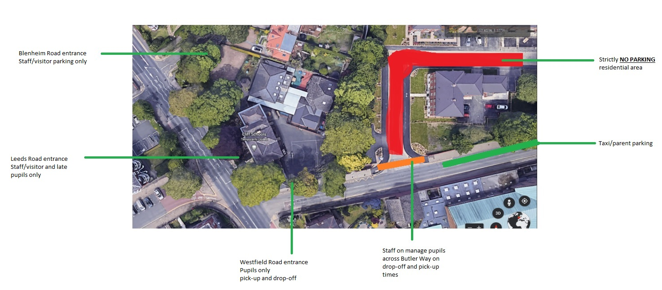

# School Timings

* Pupils should arrive no later than 8:45am
* School gates on Westfield Road entrance will open from 8:30am and close for 8:45am
* Late pupils that arrive after 8:45am must come to the front entrance on Leeds Road (please note there is no parking on Leeds Road).
* School finishes at 2:30pm
* School gates on Westfield Road will open at 2:30pm and close 2:45pm, any parent/carers/passenger assistants arriving after this time will need to report to the school office via the front entrance on Leeds Road (please note there is no parking on Leeds Road).

# Pupils

* Parents/carers/passenger assistants are required to escort the pupil to their designated pupil entrance point
* There will be a minimum of 2 staff members on Westfield Road to support pupils that use passenger transport and do not have a passenger assistant
* At the start of day, any pupil(s) that travel using school passenger transport services and do not have a passenger assistant with them will need to wait in the vehicle until a member of staff will receive them to walk into school.
* At the end of day, a staff member will walk the pupil(s) that do not have a passenger assistant to the vehicle.

# Parents

Cars should not be parking on Butler Way this is strictly residential only, on pavements or on/on the traffic lights waiting point. Alternative on street parking is available in the surrounding area, please make sure that you do not block residential driveways or park where this could cause an obstruction. Please consider our neighbours when parking in the streets around school.

# Staff/Visitors

The main car park off Blenheim Road within the school grounds may be used by designated staff only. Drivers should proceed slowly within the car park at all times, will are limited on spaces so please park considerately.

Doing so will allow unrestricted movement of other vehicles during the school day or at peak times. No parking is allowed in the space at the front door due to access by emergency services.

Alternative on street parking is available in the surrounding area, but if you are unfamiliar with the area, please make sure that you do not block residential driveways or park where this could cause an obstruction. Please consider our neighbours when parking in the streets around school.

Access into the school is only permitted from the main entrance. Visitors need to press the security buzzer located to the side of door and wait for the doors to open. All visitors must report to reception and sign in before going anywhere in the school. On departure, visitors should sign out at reception and leave the building by the main entrance door. A metal button on the wall to the right of the main doors releases them for exit.

# Servicing / Deliveries

Drivers of service vehicles (if they have not been on the site before or obtained instruction in advance) should report to the reception desk in the main building to advise the nature of their visit and get clarification on where they can park.

Drivers are to park on Blenheim Road near the school side gate but not blocking access if possible.

Drivers may be issued with a copy of this plan for reference or simply be advised of the site rules in relation to the area they are parking at the time.

Where the contractor is on site to carry out works by prior arrangement, please call the school reception on 01924 366242 or Facilities Manager on 07901 246 329 in advance to agree the most suitable parking location.

**Kitchen Service Area**

The area that provides access to the kitchen and refuse collection is designated for service vehicles only. There is clear signage in the area to identify this.

Drivers should be aware that they are working in a school environment - exercise extreme caution and be vigilant when carrying out vehicle manoeuvres in any part of the school grounds.

# Outside the School Grounds

The school accepts that parking near the school is not easy. The streets around the school are residential streets used by service buses as well as car traffic into and out of the surrounding area. It is important that the school is a good neighbour to local residents. Leeds Road is a main thoroughfare and in constant use during the day.

Parking indiscriminately, such as mounting pavements, double parking, stopping on any yellow lines, obstructing access points to streets and driveways and parking near junctions causes danger to pupils and other road users. Accidents can arise if views are obstructed, or pedestrians have to negotiate between parked vehicles. In addition, the roads can become congested which results in frustration and delays to services and ongoing journeys.

# Management Practices

Key to the ongoing monitoring of the plan is the role of the school’s Facilities team managed by the maintenance Manager. All staff have a responsibility to make sure that they are acting in such a way as to not compromise the health and safety of themselves or others.

## Monitoring of compliance against this plan

The Facilities Team will carry out regular site inspections to view practices.

Where issues arise with vehicular access, taxi/minibus drivers and staffing, these will be dealt with or escalated by the Senior Leadership Team.